# Sample Hands-on Exercises on Edge Services and API Gateway with Spring Boot 3 and Spring Cloud

Exercise 1: Implementing Edge Services for Routing and Filtering

**Task:** Implement an edge service for routing and filtering requests in a microservices architecture using Spring Boot 3 and Spring Cloud.

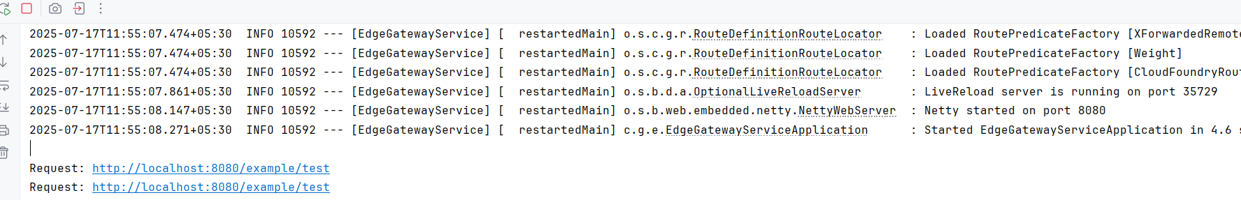

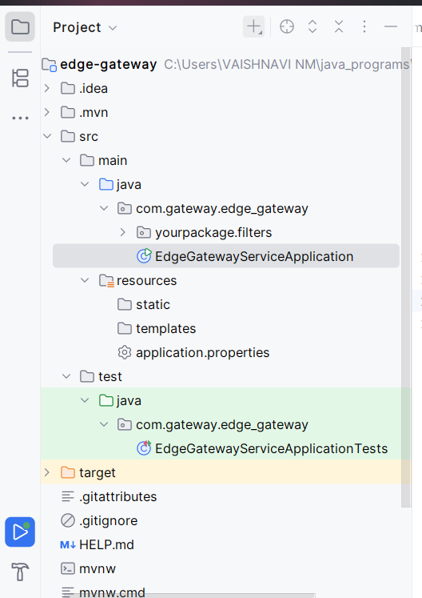

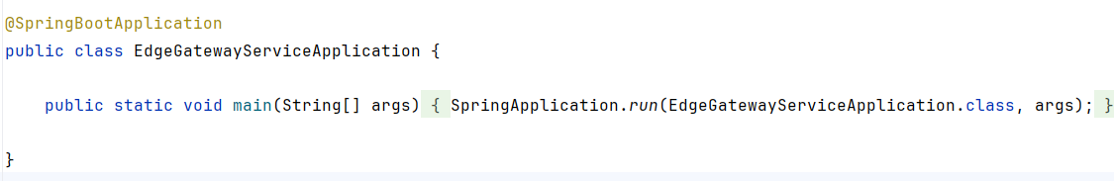

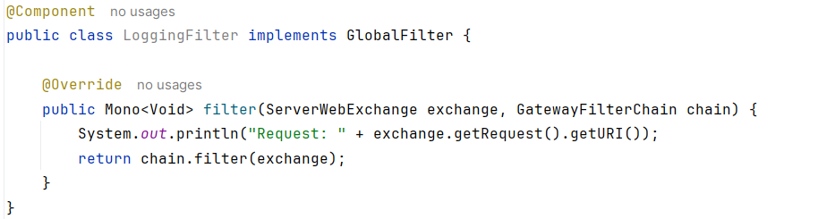

Exercise 2: Load Balancing in an API Gateway

**Task:** Implement load balancing in an API Gateway using Spring Boot 3 and Spring Cloud.